**Documentation**

***Weather analysis***

Using Python Cleaning and pre-processing the dataset.

Actually Exploratory data analysis of weather.csv is done in python. And also check the structure of the dataset, the statistics, the missing values, the duplicates, the unique values of the categorical variables by python (pandas). And also studied about the relationship between the variables.

we have already investigated if there are missings in each variable. In case there are missing values, we need to understand how to handle the issue. The easiest way would be to remove the variables or the rows that contain NaN values, but we would prefer to avoid it because we risk losing useful information that can help our machine learning model on solving the problem. If we are dealing with a numerical variable, there are several approaches to fill it. The most popular method consists in filling the missing values with the mean/median of that feature. And also using outliers duplicate data in the dataset, delete the duplicated rows

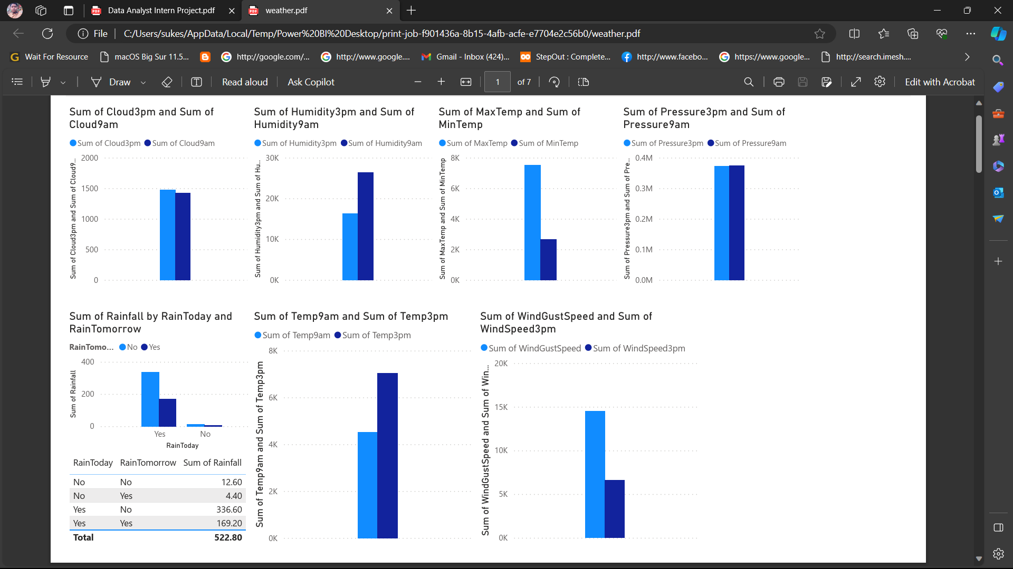**Advanced Analysis with Power BI**

**By this today is rain predicted**

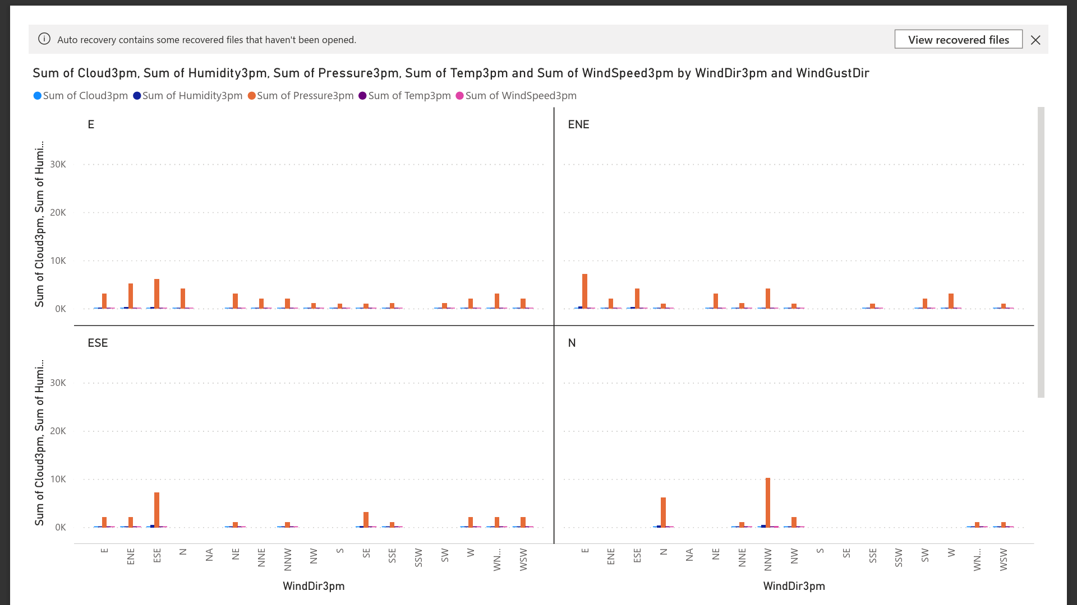

**All these graph decipts various kinds of parameters and the chances to happened by the corelating the various parameters and their chances like rain, pressure, Evaporation,temp, Humidity. All these parameters through the graphical representation by this we predict the weather conditions by analysing the respected graphs given above.so there will we can make a weather analysis report.**

**-------------------------------------**